*Florida International University*

*School of Computing and Information Sciences*

Software Engineering Focus

Feature Document

User Story ID #343

**Name:** Add Folder/Category Security Based on Officer's Shift.

**Team Member(s):** Darilys Pereira

**Project:** Virtual Roll Call 4.0

**Product Owner(s)**: Jason Cohen

**Mentor(s)**: Juan Caraballo

**Instructor**: Masoud Sadjadi

**User Story Name:** Add Folder/Category Security Based on Officer's Shift.

* Description: **As a** Officer **I would like** to only see folders that contain information for my current shift so I can review information that pertains only to my shift.

Acceptance Criteria

* Supervisors and Administrators can see all folders/categories.
* Officers can only see folders for their current shift.
* When supervisors create folders/categories, shift visibility must be assigned to the category.
* Folder/category visibility can be setup for multiple shifts.
* Category visibility can be updated at any time.

**Use Case**

* Name: Add Category
* Actor: Administrator
* Preconditions:

1. System is up and running
2. Administrator has successfully logged into the system.
3. Connection to the database has been established.
4. Shift has been created in the system.
5. Officer has been assigned to a specific shift.

* Description:

1. Administrator clicks on Document Categories option in the system
2. Administrator adds a new document category by entering the name and the list of shifts that will have access to the category.
3. Administrator clicks the Add button.
4. System views are updated based on the new category security.

**Use Case Diagram**

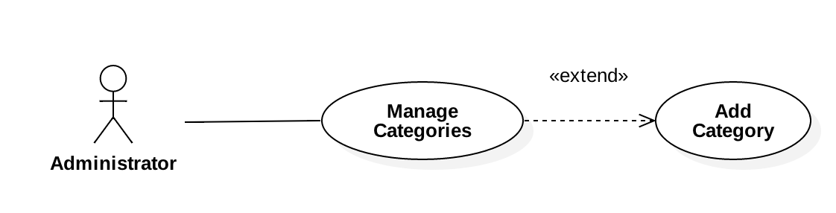

**Sequence Diagram**

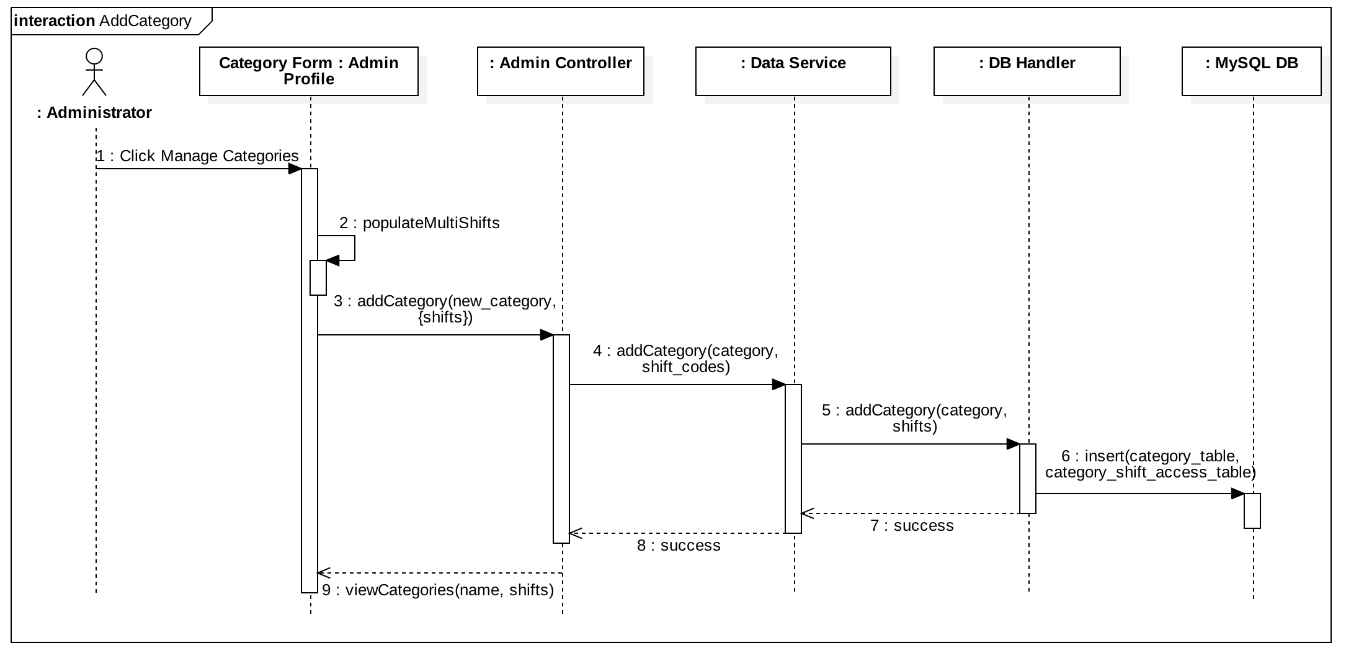

**Class Diagram**

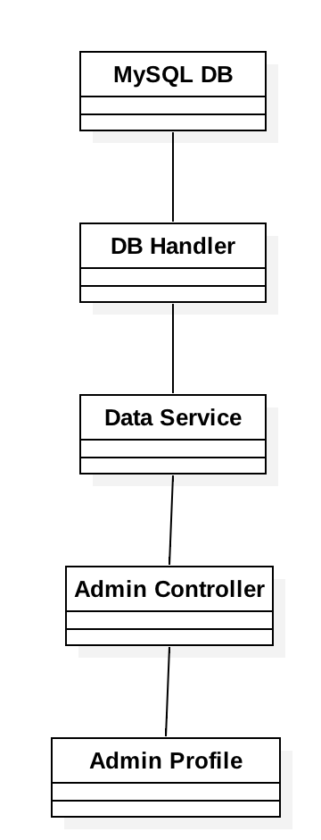

**Unit Test**

Test 1

* Test case ID: User Story #343 -Add folder/category security based on officer's shift. - Sunny Day
* Description/Summary of Test: Verify user is able to see categories associated with his/her shift.
* Pre-condition:

1. User logs in
2. User clicked the Dashboard option in the navBar

* Expected Results: User should view categories he/she has access to see based on the shift assigned.
* Actual Result: Verified user is able to see the expected category folders in the Dashboard.
* Status (Fail/Pass): Passed.

Test 2

* Test case ID: User Story #343 - Add folder/category security based on officer's shift. - Rainy Day
* Description/Summary of Test: Verify only authorized categories are viewed by officers when after login.
* Pre-condition:

1. User logs in
2. User clicked the Dashboard option in the navBar

* Expected Results: User is unable to see categories that below to other shifts.
* Actual Result: Verified user only sees the expected category folders in the Dashboard. User is unable to see categories that are not associated to his/her shift.
* Status (Fail/Pass): Passed.

**Integration Test**

Tested system by:

1. Creating a user and assigned a specific shift.
2. Creating multiple categories and assigned different shift access.
3. Uploading test files for each category.
4. Signing in as a user and verified user is only able to see authorized categories.
5. Logged in as an administrator and verified administrator is able to see all category.

Results: User was able to review documents within category. All modules of the application behaved as expected after the new functionality was developed.

Status (fail/Passed) : Passed

**Visual User Guide**

Category Management:

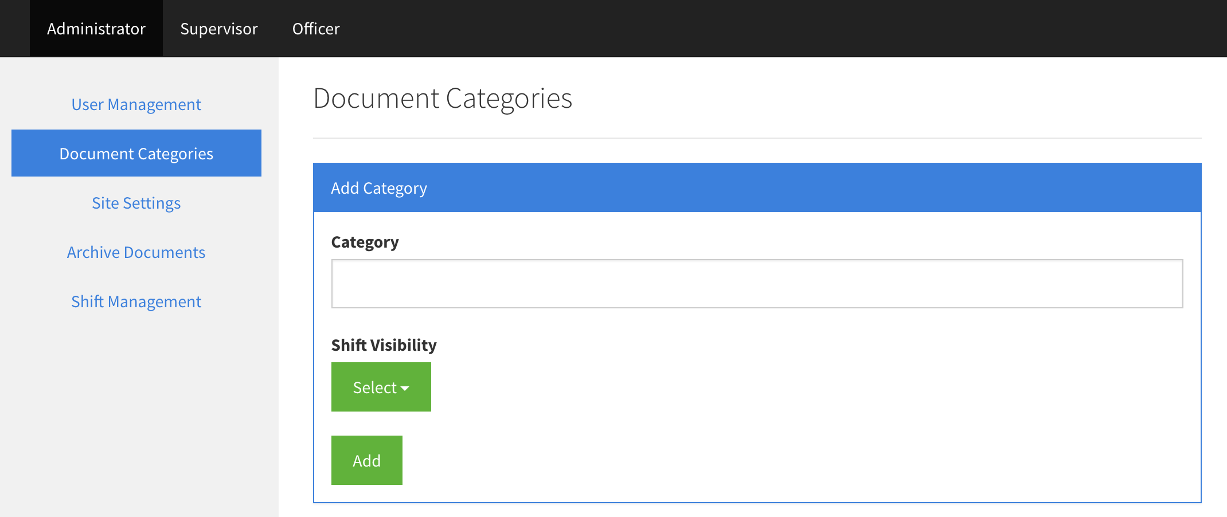

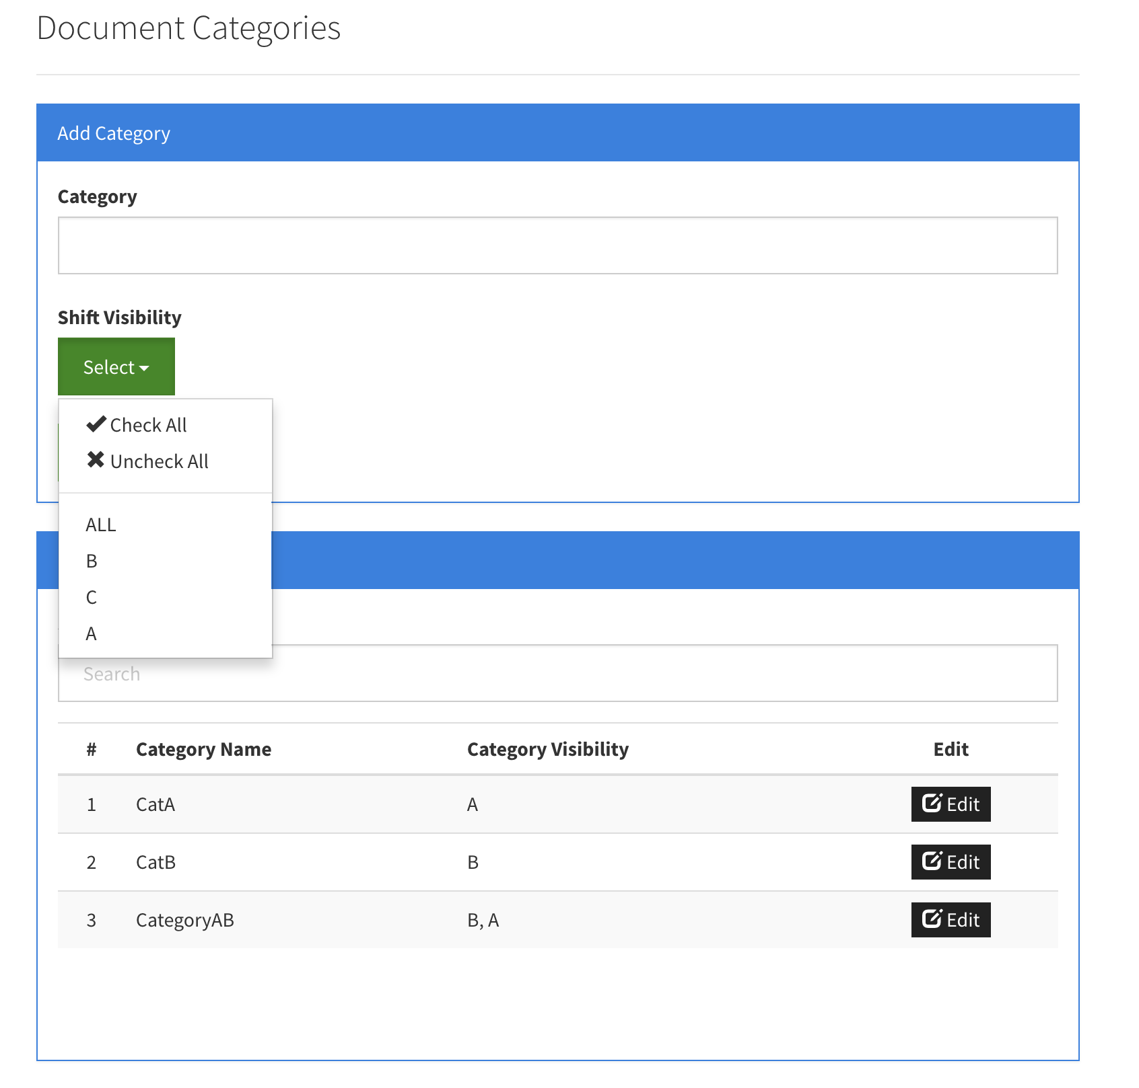

User View: User only has access to see Category A

